**💡 Tech Development FAQs**

**1. What technologies do you specialize in?**

We work with a wide range of technologies including PHP, Laravel, React, Node.js, Python, Flutter, MySQL, and more. Our stack is always tailored to your project needs.

**2. Can you build both websites and mobile apps?**

Yes, we provide end-to-end development for web platforms and mobile applications (Android & iOS), including backend, frontend, and API integrations.

**3. Do you offer custom software development?**

Absolutely. We build fully customized solutions from scratch — whether it’s a CRM, ERP, eCommerce platform, or a booking system.

**4. How long does a typical project take?**

It depends on the scope. Simple websites can take 1–2 weeks, while complex web apps may take 4–12 weeks. We’ll share a detailed timeline after understanding your requirements.

**5. Can I see the progress during development?**

Yes. We provide weekly updates, demo links, and access to test environments so you're always in the loop.

**6. Do you handle hosting and domain setup?**

Yes, we can help you with domain registration, hosting setup, server configuration, and deployment.

**7. What if I need changes after the project is done?**

We offer post-launch support and maintenance packages. Minor changes are handled even after launch as part of our customer-first approach.

**8. Is my data secure?**

Yes, we follow industry-standard security practices, including HTTPS, secure APIs, encrypted storage, and regular code audits.

Remove sheikh  


User Relevance icons  
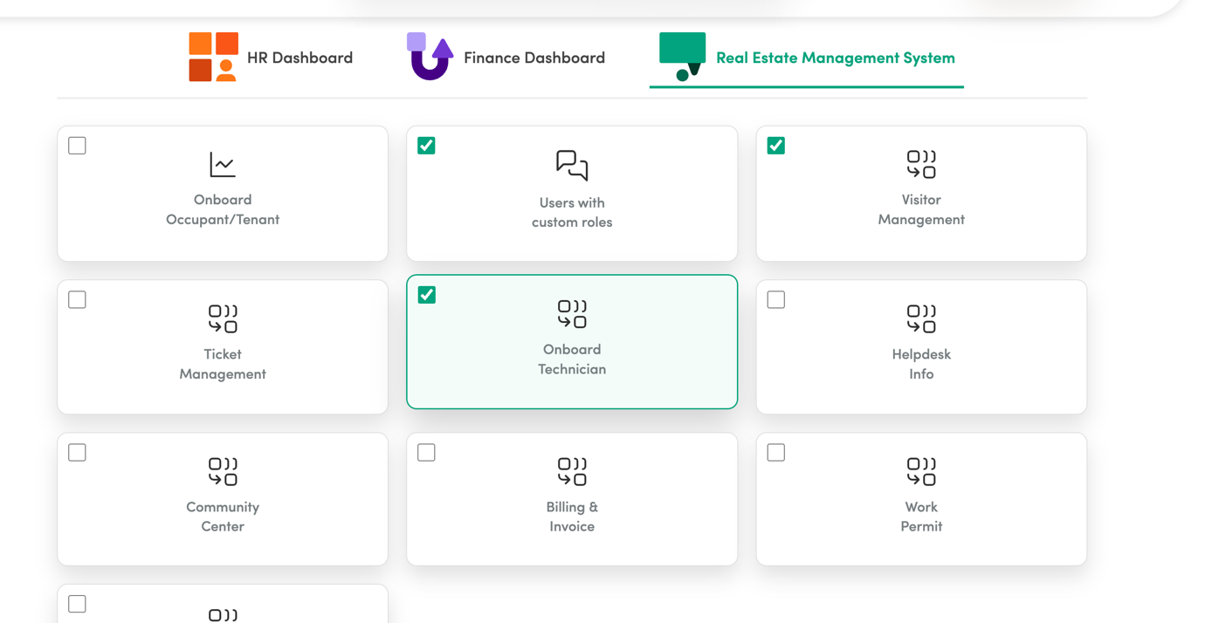

Add More Features replace Our Services  
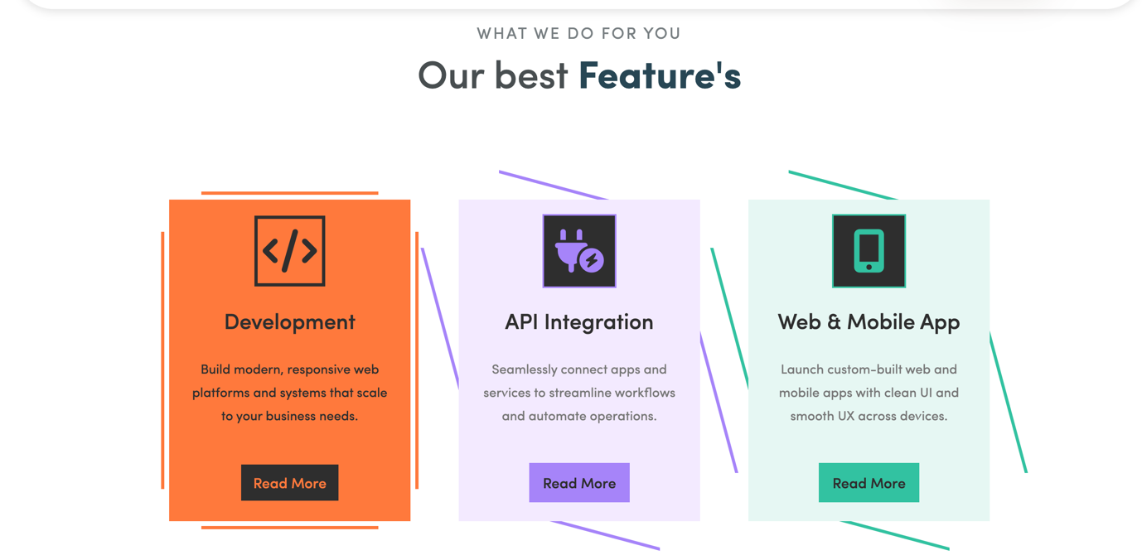

Use 2 rows of 4 cards in Our services section  
  
• **Mobile & Web App Development**  
Custom Android, iOS, and web applications tailored to your business goals.

• **API Integration & Development**  
Seamless integration of third-party services or development of custom RESTful APIs.

• **UI/UX Design**  
User-centered design for web and mobile interfaces with modern, responsive layouts.

• **Custom Software Development**  
Bespoke software solutions like CRMs, ERPs, dashboards, and internal tools.

• **E-commerce Development**  
End-to-end online store development with payment gateways, inventory, and user management.

• **CMS & Website Development**  
Dynamic and SEO-friendly websites using Laravel, WordPress, or custom frameworks.

• **Cloud Hosting & DevOps**  
Server setup, CI/CD pipelines, cloud deployment (AWS, DigitalOcean, etc.), and maintenance.

• **Maintenance & Technical Support**  
Ongoing updates, bug fixes, and performance optimization post-launch.

Use Preview Slider  
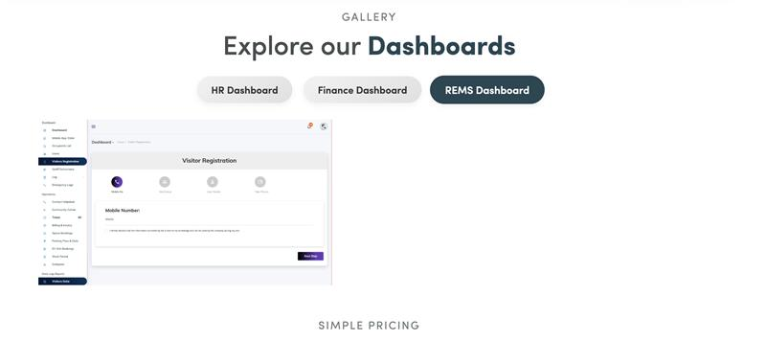

Sample  
[https://codepen.io/peppino999/pen/raBVBpy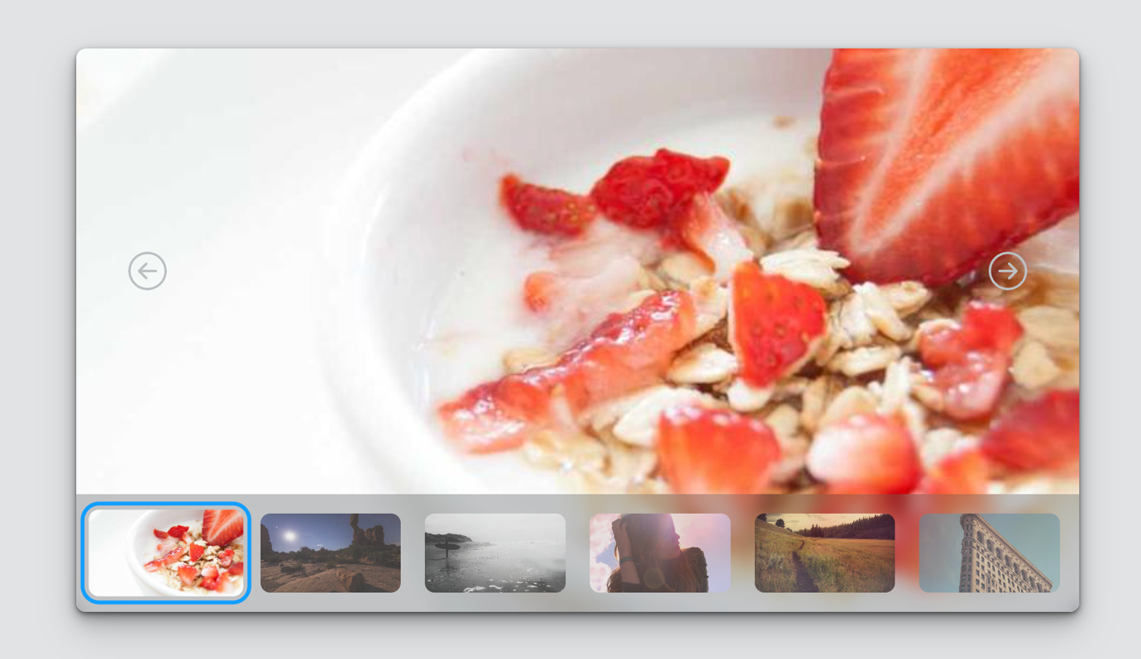](https://codepen.io/peppino999/pen/raBVBpy)  
  
  
Other URLS  
For API Sectors  
<https://codepen.io/joydippaul9/pen/dyQymYy>  
<https://codepen.io/codewithshabbir/pen/JoPwMOv>  
<https://codepen.io/nathan-sr/pen/ZEqPVJm>

LOG IN PAGE  
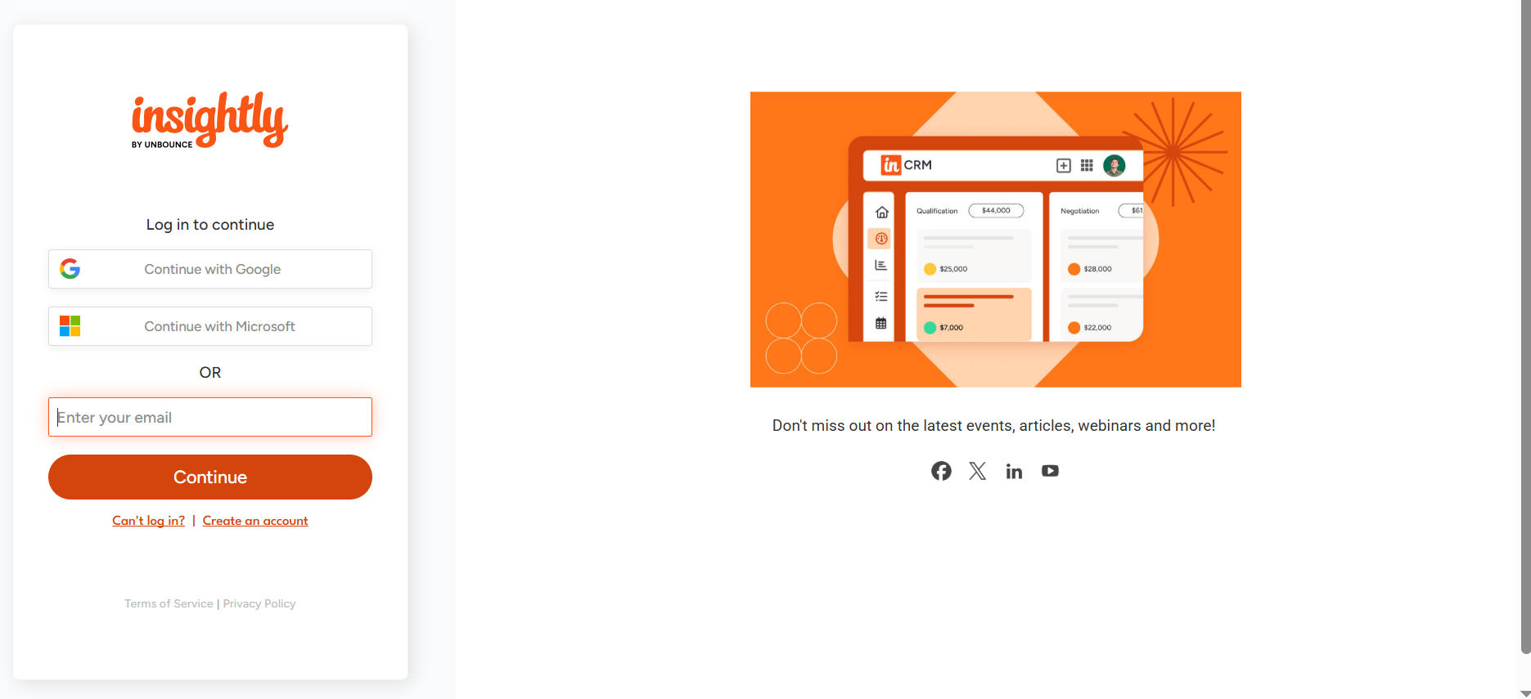

TRY CRM FOR FREE  
  
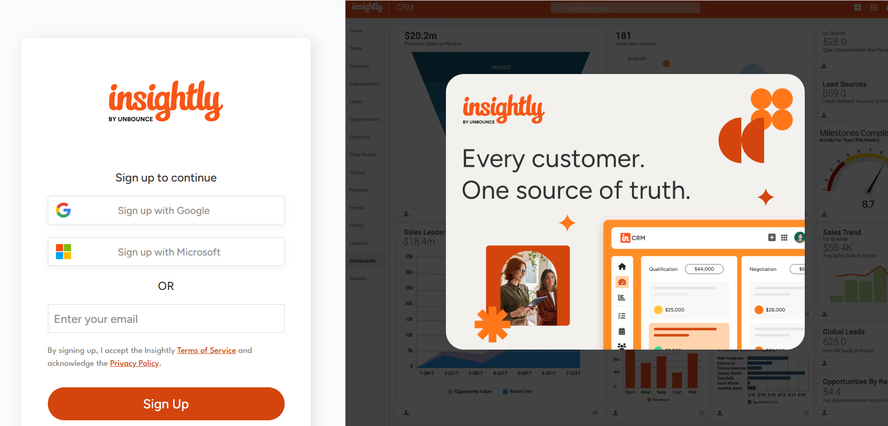

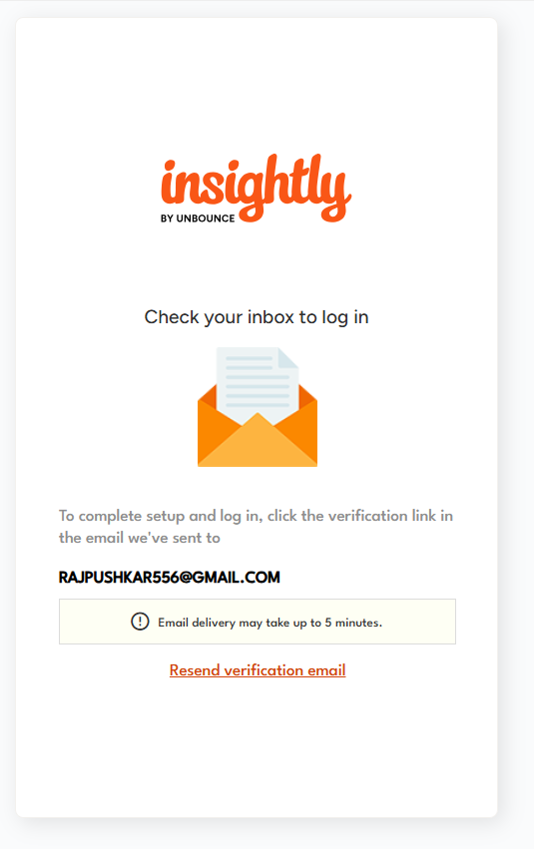

MAIL TEMPLATE  
